

|  |
| --- |
| Name of the Student: Neha Gupta |
| Class and Div and Roll No: TE-1/49 |
| Experiment No.5 |
| Use Wire shark to understand the operation of TCP/IP layers |
| Date of Performance: 05-08-2025 |
| Date of Submission: 12-08-2025 |

**Experiment No 5**

# Aim: Use Wireshark to understand the operation of TCP/IP layers

**Theory:**

Wireshark is an open-source packet analyzer, which is used for education, analysis, software development, communication protocol development, and network troubleshooting. It is used to track the packets so that each one is filtered to meet our specific needs. It is commonly called as a sniffer, network protocol analyzer, and network analyzer. It is also used by network security engineers to examine security problems. Wireshark is a free to use application which is used to apprehend the data back and forth. It is often called as a free packet sniffer computer application. It puts the network card into an unselective mode, i.e., to accept all the packets which it receives.

The following are some of the many features Wireshark provides:

* Available for UNIX and Windows.
* Capture live packet data from a network interface.
* Open files containing packet data captured with tcpdump/WinDump, Wireshark, and many other packet capture programs.
* Import packets from text files containing hex dumps of packet data.
* Display packets with very detailed protocol information.
* Save packet data captured.
* Export some or all packets in a number of capture file formats.
* Filter packets on many criteria.
* Search for packets on many criteria.
* Colorize packet display based on filters.
* Create various statistics.

**Procedure:**

1. Download Wireshark tool sudo apt install wireshark
2. Install with default settings
3. After opening wireshark select either wifi or ethernet based on your connect
4. Check dns
5. Apply udp/ tdp filter also

**Output:**

* **DNS CONNECTION (WINDOWS):**

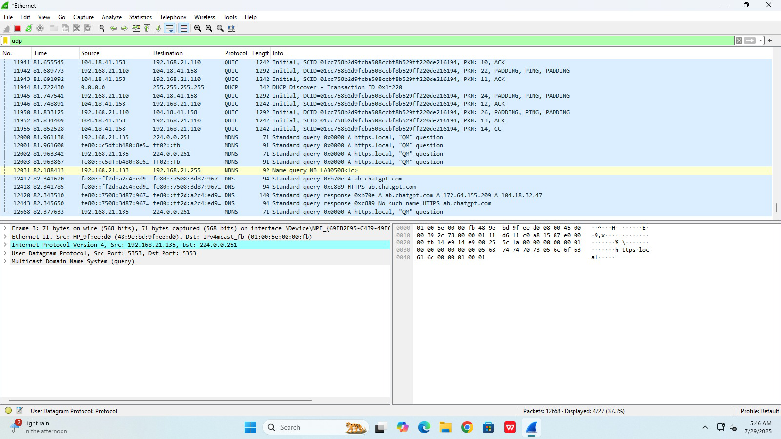

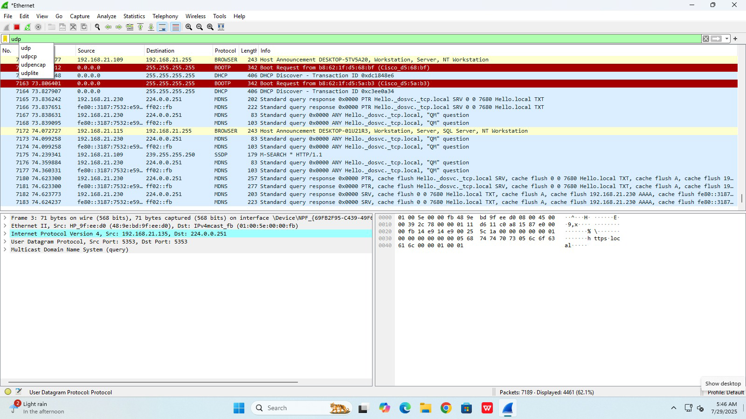

* **TCP CONNECTIONS (WINDOWS):**

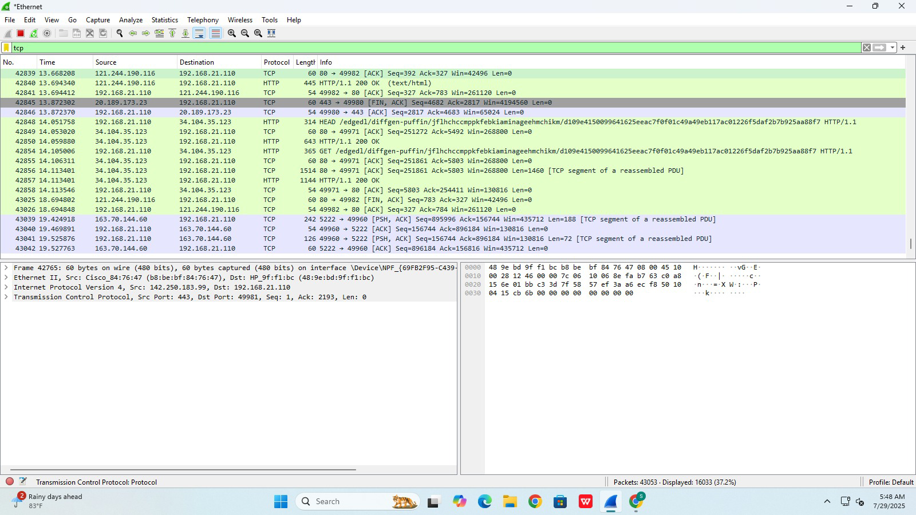

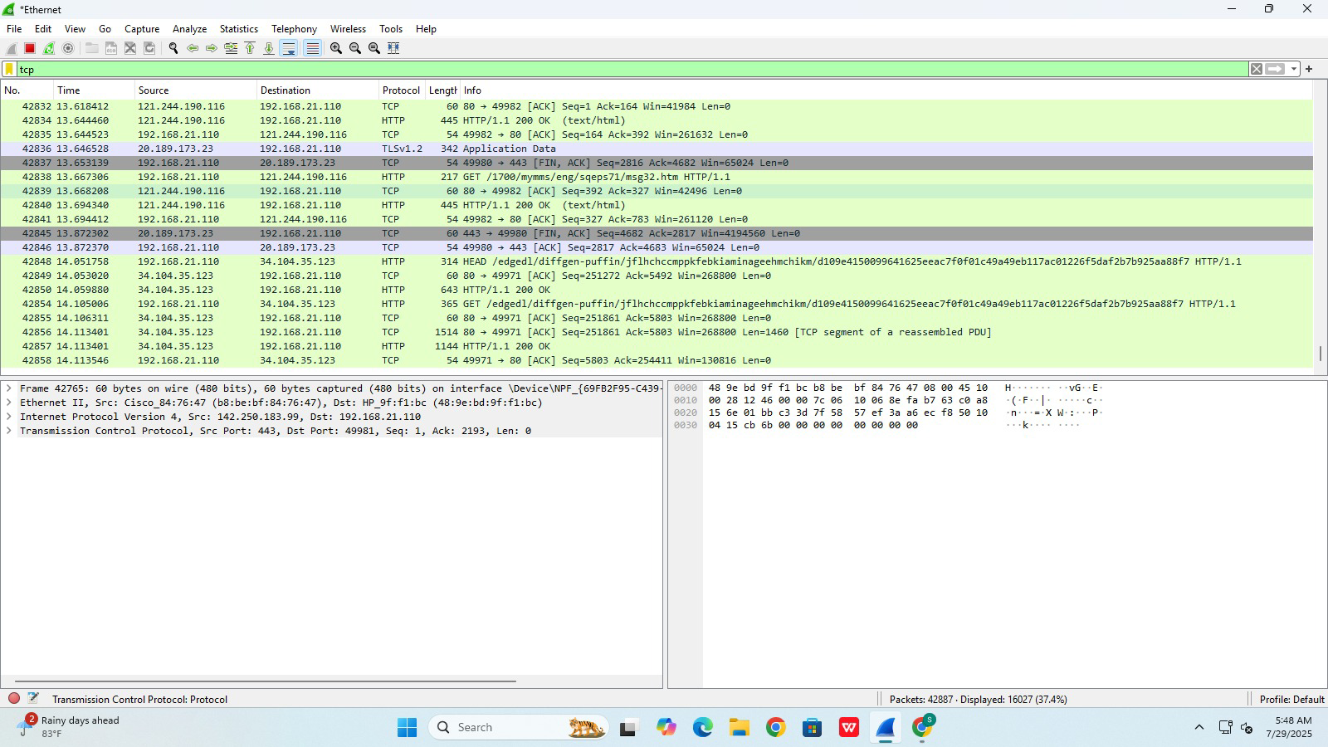

* **DNS CONNECTIONS (WINDOWS):**

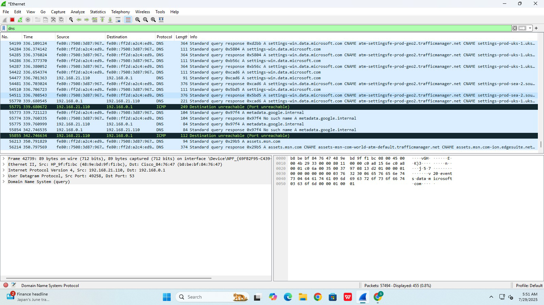

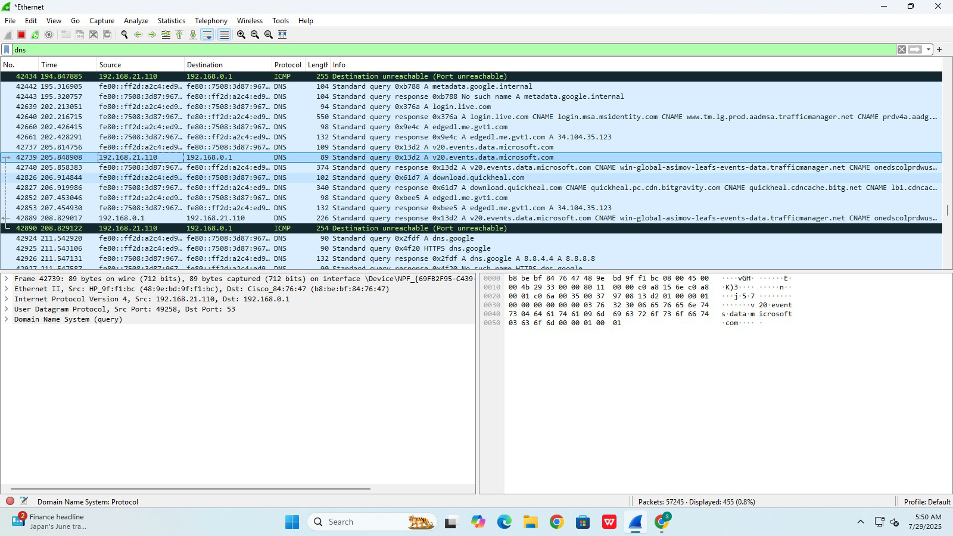

* **ETHERNET CONNECTIONS (WINDOWS):**

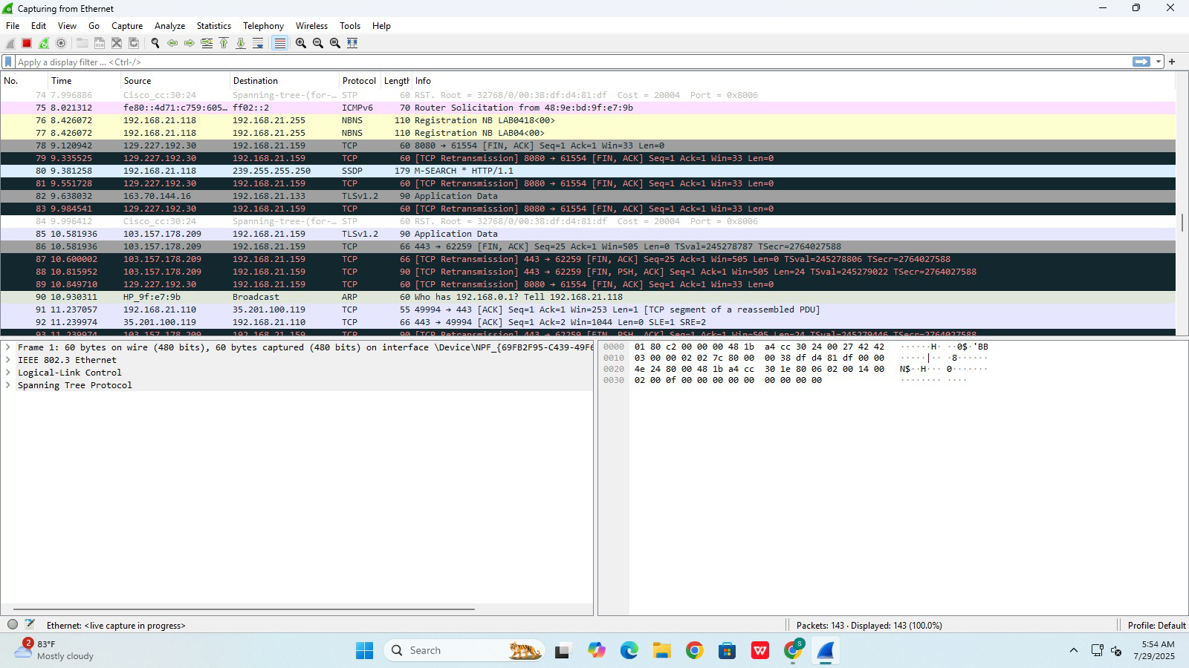

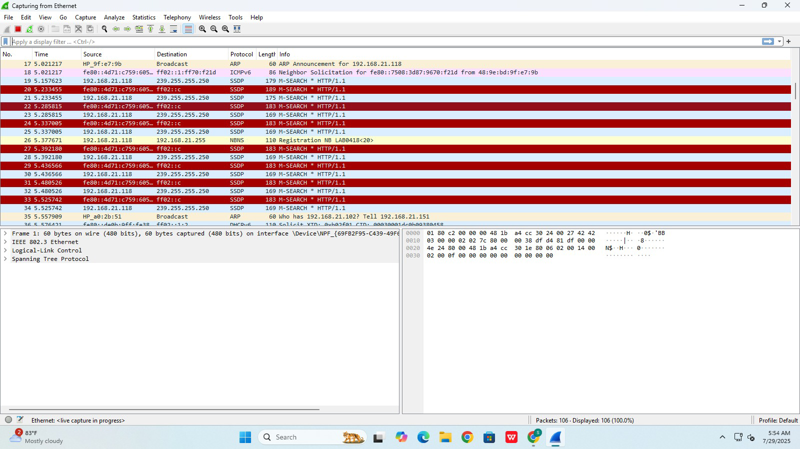

* **WI-FI CONNECTIONS (WINDOWS):**

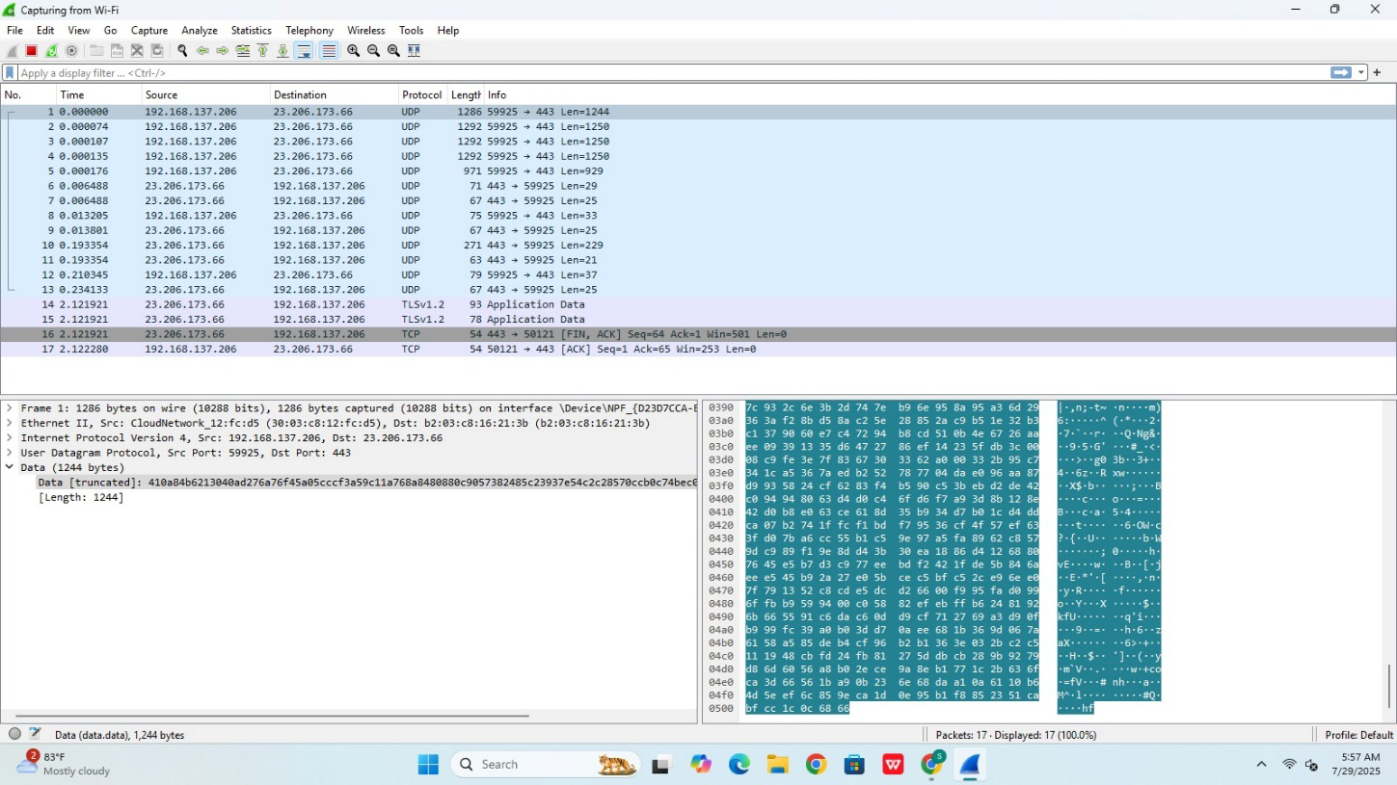

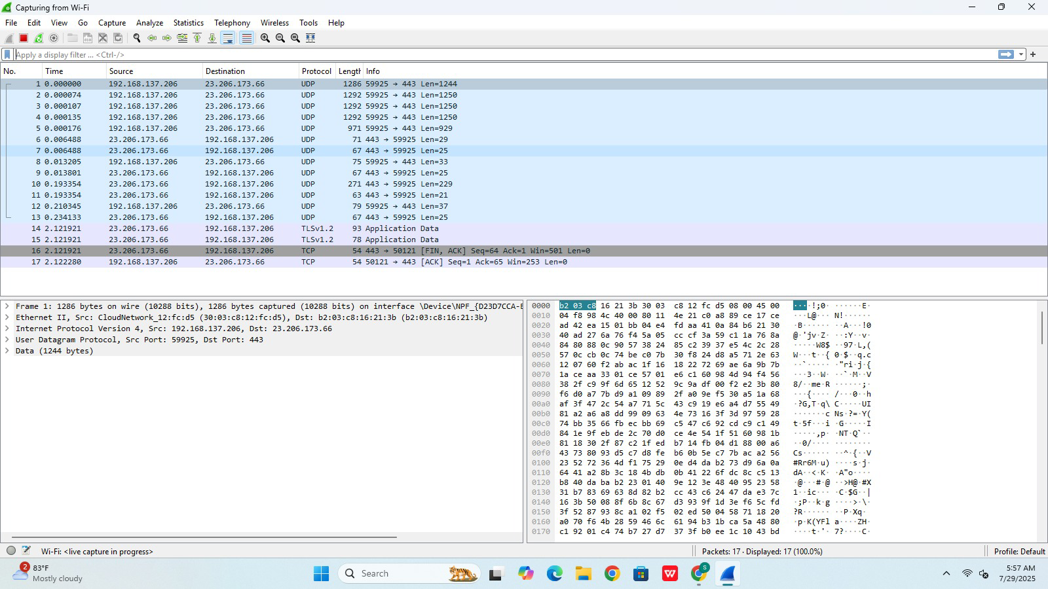

# TCP CONNECTIONS (LINUX):

# 

# UDP CONNECTIONS (LINUX):

# 

# ETHERNET CONNECTIONS (LINUX):

# 

# DNS CONNECTIONS (LINUX):

# 

# 

# Conclusion:

Thus in this practical we have used Wireshark tool to study the machine’s IP address at the time of packet capture and port number.

# Questions:

1. What is Wireshark?

ANS: Wireshark is a free and open-source network protocol analyzer used to capture and analyze data packets traveling across a network for troubleshooting, monitoring, and security analysis.

1. How can Wireshark help in understanding TCP/IP layers?

ANS: Wireshark helps in understanding TCP/IP layers by capturing packets and displaying them in a layered view, showing details from each layer (Application, Transport, Network, Data Link). This allows you to analyze how data moves through the stack, troubleshoot issues, and study protocols at each layer.

1. Which layer of the TCP/IP model does the IP protocol belong to?

ANS: The IP (Internet Protocol) belongs to the **Network layer** of the TCP/IP model.

1. In Wireshark, how can you capture only TCP packets?

ANS: In Wireshark, you can capture only TCP packets by applying a **capture filter**

1. What display filter is used to show only HTTP traffic in Wireshark?

ANS: The display filter used to show only HTTP traffic in Wireshark is: http```